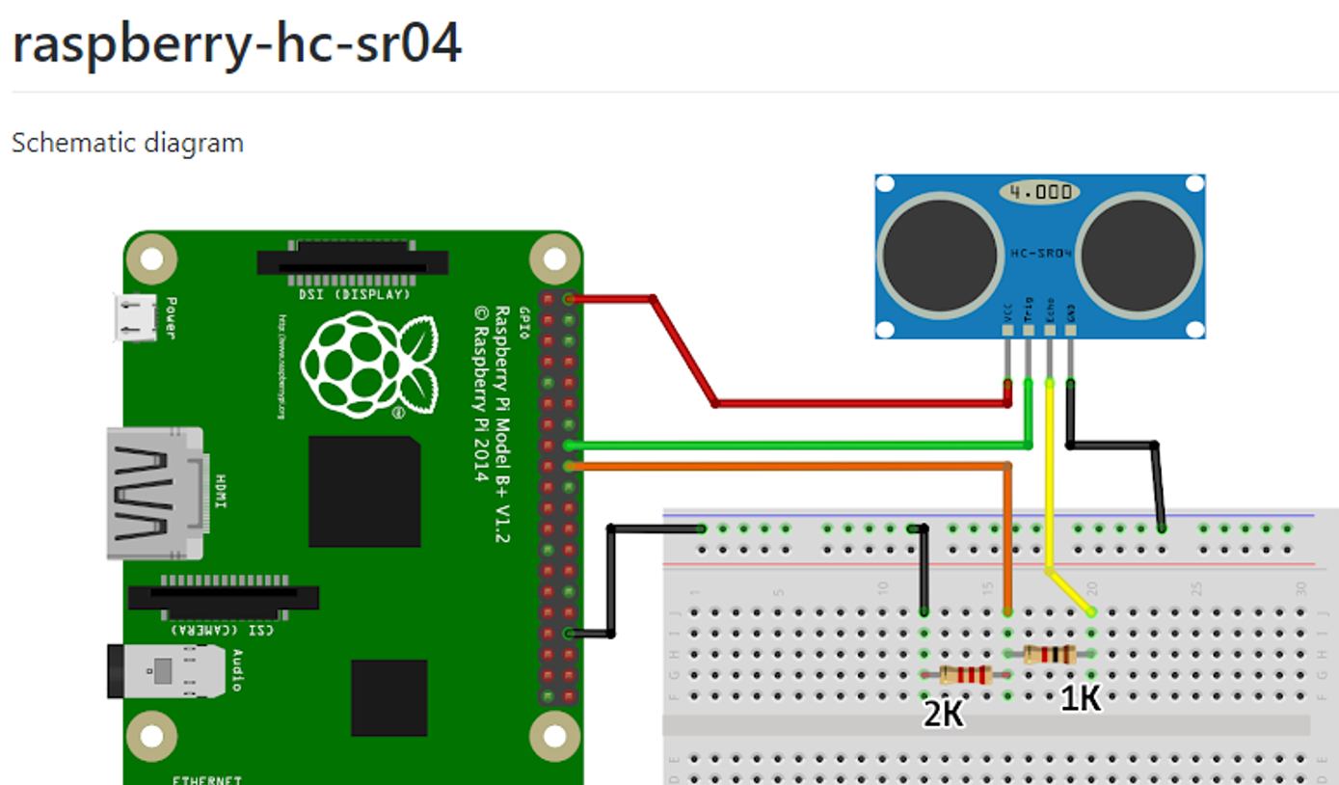

Voltage Divider

The ECHO output is of 5v. The input pin of Raspberry Pi GPIO is rated at 3.3v. So 5v cannot be directly given to the unprotected 3.3v input pin. Therefore, we use a voltage divider circuit using appropriate resistors (2:1) to bring down the voltage to 3.3V.

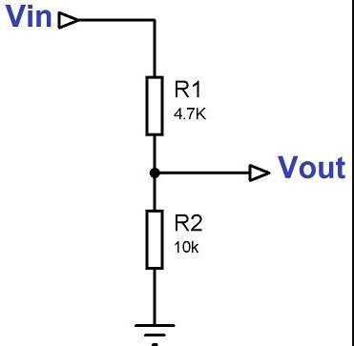

**HANDOUT 1 – SMART BIN SYSTEM**

PIN 24

PIN 23

GND

5V

**P24 3.3V**